**EECT6379 - Energy Harvesting, Storage and Powering for Microsystems**

**Second Project Assignment | Devang Sankhala (dgs150030) | April 11, 2017**

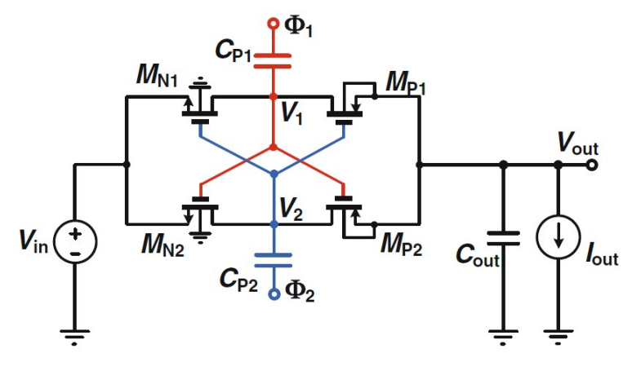

**Process files**

TSMC 0.35 um process files were used for this assignment. Important characteristic values are given.

|  |  |  |
| --- | --- | --- |
| **Parameter** | **NMOS** | **PMOS** |
| µCox | 150 µA/V2 | 30 µA/V2 |
| Threshold voltage | 0.5 V | 0.7 V |
| Lambda | 0.01 | 0.015 |

**Sizing**

|  |  |  |  |  |
| --- | --- | --- | --- | --- |
| **Designator** | **W m** | **L m** | **Multiplier** | **Active area** |
| MN1 | 4E-06 | 3.50E-07 | 100 | 1.40E-10 |
| MN2 | 4E-06 | 3.50E-07 | 100 | 1.40E-10 |
| MP1 | 4E-06 | 3.50E-07 | 400 | 5.60E-10 |
| MP2 | 4E-06 | 3.50E-07 | 400 | 5.60E-10 |
|  |  |  | **Total** | **0.0014mm2** |

First, for the switch transistor, based on the peak load current and drain-source voltage extremes, the sizing is decided.

$$I_{D}= k \frac{W}{L} (V_{GS}-V_{TH}) V_{DS}$$

Here, a drop of 25 mV and 2 mA peak current is assumed across all switches. The overdrive is assumed to be 0.7 V. The clock signal peaks are at 1.4 V, but the gate sees 1.4 V plus the voltage on the pumping capacitors. This adds to the advantage of this charge pump design. The sizing is chosen to allow common centroid layout.

**Pumping capacitors and conversion gain**

The conversion gain of this charge pump is expressed by

$$CG= \frac{2}{1+ \frac{1}{2R_{out}C_{p}f_{s}}}$$

For the given problem, the conversion gain is 2, thus the denominator of the above equation should be close to 1. Assume CG = 1.964, i.e. output voltage of **2.75 V**. Assume switching frequency of 100 kHz. Also, for worst case output resistance

$$R_{out,min}= \frac{V_{out}}{I_{out,max}}=\frac{2.75V}{1mA}=2750 ohm$$

Using above values, we find the pumping capacitor value of 101 nF, which can be rounded off to **100 nF**.

**Output Capacitor and output ripple**

As per specification, we target a 10-mV ripple. The below equation holds because both phases of the clock allow discharge of the pumping capacitors. This ensures that there are no ESR jumps in the output voltage waveform. Solving below equation for max load of 1 mA and switching frequency of 100 kHz, we get a minimum output capacitor of **470nF**.

$$ΔV_{o}=\frac{I_{o}}{2f_{s}C_{out}}$$

**Circuit**

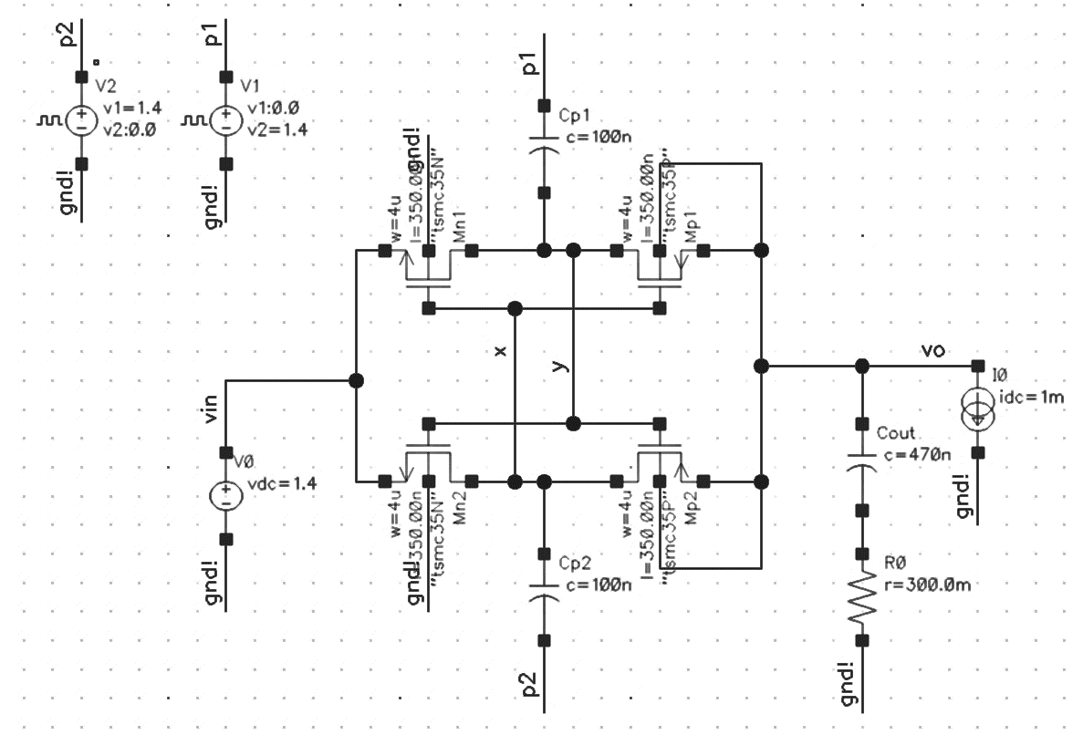

**Steady State Waveforms**

